Database Technologies – Assignment 9
1. Create an index that will enable a user to pull orders for ‘1990-10-03’ out of the Orders table quickly.
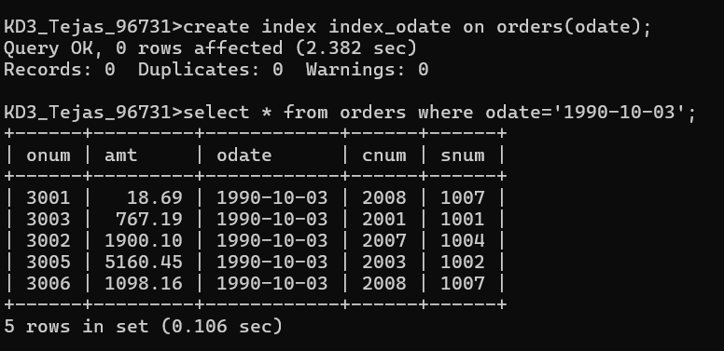
2. If the Orders table has already been created, how can you force the onum field to be unique (assume all current values are unique)?
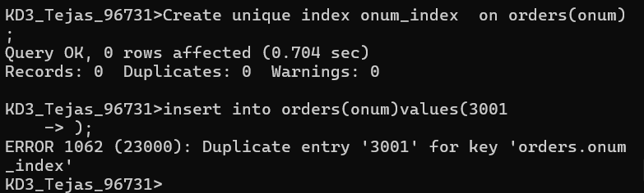
3.Create an index that would permit salesperson to retrieve his orders.
4. Let us assume that each salesperson is to have only one customer of a given rating, and this is currently the case. Create an index that enforces it.

5.Create an index to speed up searching order on a given date by given customer.
